Annexure A: Constraint-Based Problem Solving

a) PEAS Description
Component | Description
Performance measure | Number of constraint violations (target: zero clashes between conflicting courses); all 5 exams assigned to a slot; number of slots used (at most 3); computation time / search effort; optionally fairness (balanced load per day, gaps for students).
Environment | Set of 5 courses, 3 exam slots (one per day), the student-enrolment overlap data and the 7 conflict pairs (A-B, A-C, B-C, B-D, C-D, C-E, D-E). Static, fully observable, deterministic, discrete, single-agent.
Actuators | Assigning / reassigning a course to a slot, publishing the timetable, flagging unsolvable conflicts, notifying students and faculty.
Sensors | Enrolment database (shared-student information), list of available slots, current partial timetable, constraint-violation checker, new registration or slot-change inputs.

Input:

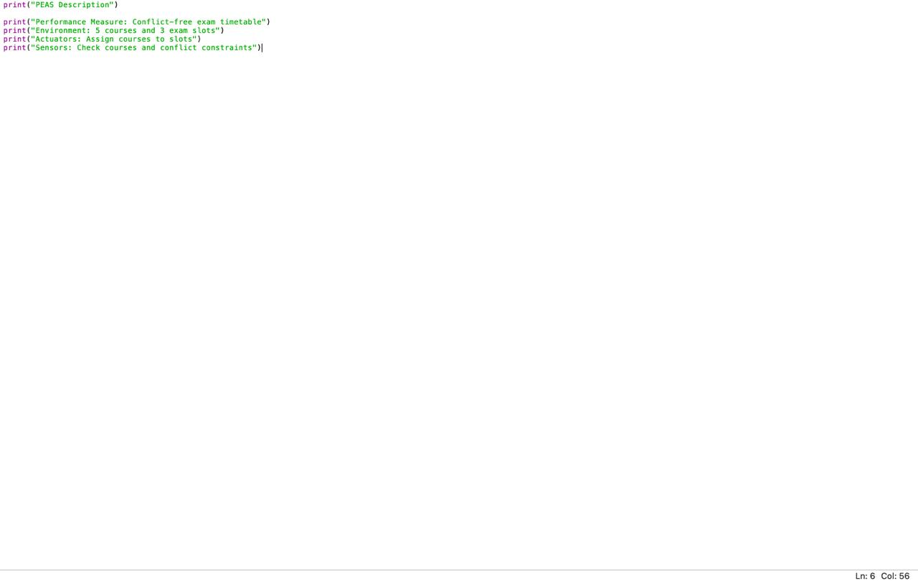
Output:
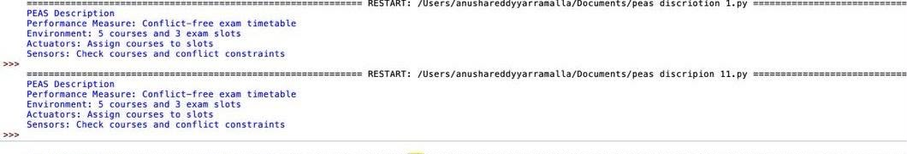

b) Type of Agent
Best suited: goal-based agent (with a utility-based extension only if soft preferences are added).
Clear goal state. The goal is explicit and binary: a complete assignment of all courses to slots with no conflicting pair sharing a slot.
Reflex agents fail. A simple reflex agent reacts only to the current percept and cannot plan a sequence of assignments; one wrong early choice may make the later ones impossible.
Beyond model-based. A model-based agent keeps state but still has no goal, so it does not know when it is done. The goal-based agent keeps the partial timetable as its model and searches (backtracking, forward checking) toward the goal.
Not utility-based. All that matters here is satisfiability of hard constraints. There is no numeric preference (such as minimising gaps) that would require utility maximisation, so a utility-based agent is unnecessary.

Input:
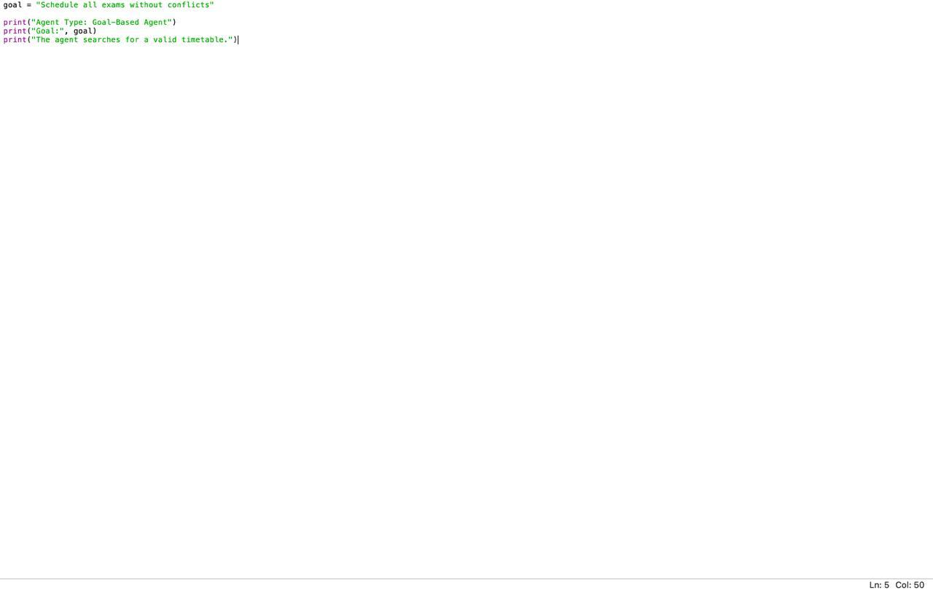

Output:
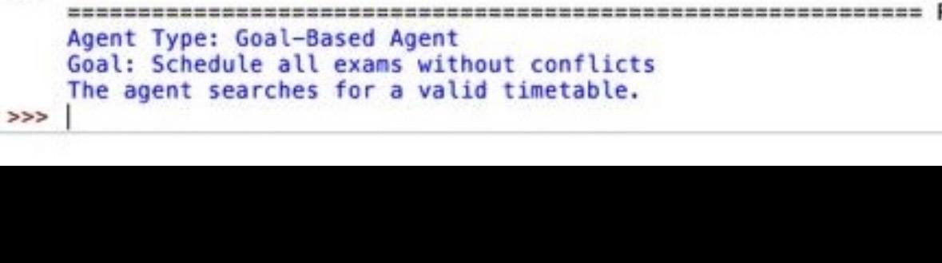

c) CSP Formulation
Element | Definition
Variables | X = {A, B, C, D, E}, one per course (the slot of that exam).
Domains | D(A) = D(B) = D(C) = D(D) = D(E) = {Slot1, Slot2, Slot3}
Constraints | Binary inequality constraints: A != B, A != C, B != C, B != D, C != D, C != E, D != E (each pair must receive different slots).

Constraint graph
Vertices: A, B, C, D, E (5 vertices).
Edges: (A,B), (A,C), (B,C), (B,D), (C,D), (C,E), (D,E) (7 edges).
Vertex | Degree | Neighbours
A | 2 | B, C
B | 3 | A, C, D
C | 4 | A, B, D, E
D | 3 | B, C, E
E | 2 | C, D
The graph contains the triangles A-B-C, B-C-D and C-D-E, so at least 3 slots are required. The problem is exactly 3-colouring of this graph.

Input:
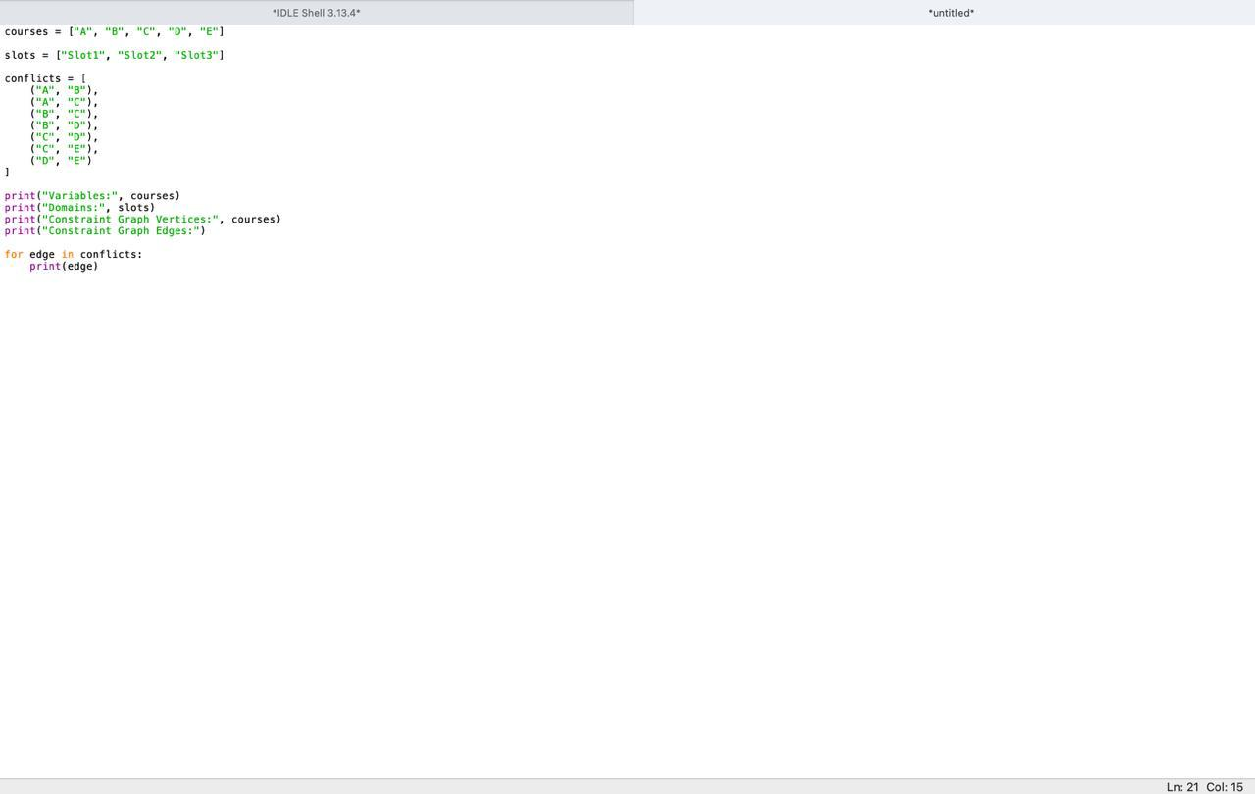

Output:
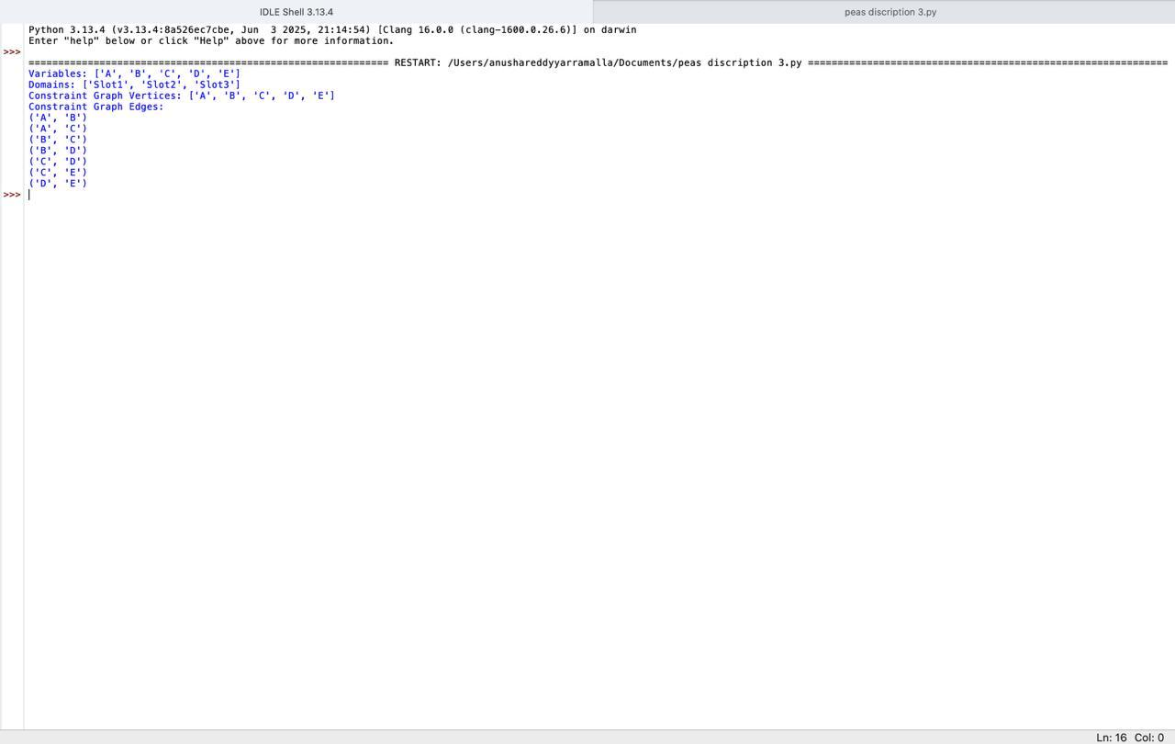

d) Plain Backtracking Search
Variable order: A, B, C, D, E. Value order: Slot1, Slot2, Slot3. A value is checked only against already-assigned neighbours.
Step | Variable | Value tried | Check against assigned neighbours | Result
1 | A | Slot1 | No assigned neighbours | Accept: A=S1
2 | B | Slot1 | A=S1 (conflict A-B) | Reject
3 | B | Slot2 | A=S1 differs | Accept: B=S2
4 | C | Slot1 | A=S1 (conflict A-C) | Reject
5 | C | Slot2 | B=S2 (conflict B-C) | Reject
6 | C | Slot3 | A=S1, B=S2 differ | Accept: C=S3
7 | D | Slot1 | B=S2, C=S3 differ | Accept: D=S1
8 | E | Slot1 | D=S1 (conflict D-E) | Reject
9 | E | Slot2 | C=S3, D=S1 differ | Accept: E=S2 (complete)
Shaded rows are rejected attempts. Every rejected value was replaced by the next value of the same variable. No variable ever had its whole domain exhausted, so there was no need to return to a previously assigned variable (0 backtracks to earlier variables).
Final timetable: A = Slot1, B = Slot2, C = Slot3, D = Slot1, E = Slot2.
Slot | Courses | Check
Slot1 (Day 1) | A (AI), D (OS) | A-D is not a conflict pair
Slot2 (Day 2) | B (DBS), E (SE) | B-E is not a conflict pair
Slot3 (Day 3) | C (CN) | -
All 7 constraints verified: A!=B (S1,S2), A!=C (S1,S3), B!=C (S2,S3), B!=D (S2,S1), C!=D (S3,S1), C!=E (S3,S2), D!=E (S1,S2).

Input:
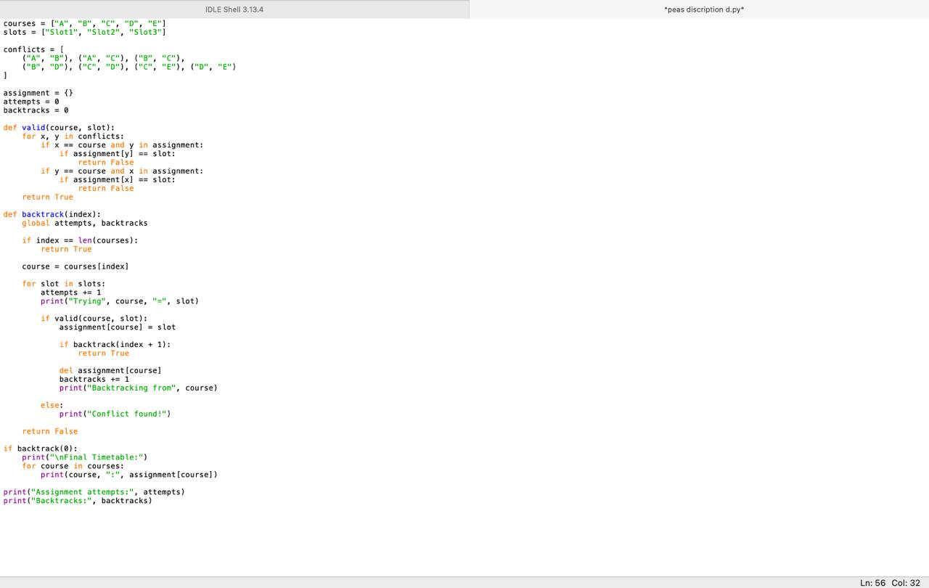output:
:

e) Backtracking with Forward Checking
After each assignment, the value is removed from the domain of every unassigned neighbour. If any domain becomes empty, the assignment is undone immediately. Same variable and value order as before.
Step | Assignment | A | B | C | D | E | Pruning / Remark
0 | Initial | {1,2,3} | {1,2,3} | {1,2,3} | {1,2,3} | {1,2,3} | Full domains
1 | A = Slot1 | 1 | {2,3} | {2,3} | {1,2,3} | {1,2,3} | S1 removed from B, C (neighbours of A)
2 | B = Slot2 (S1 no longer in D(B)) | 1 | 2 | {3} | {1,3} | {1,2,3} | S2 removed from C, D. No empty domain
3 | C = Slot3 (only value) | 1 | 2 | 3 | {1} | {1,2} | S3 removed from D, E
4 | D = Slot1 (only value) | 1 | 2 | 3 | 1 | {2} | S1 removed from E
5 | E = Slot2 (only value) | 1 | 2 | 3 | 1 | 2 | Complete, no wipe-out
In the table, 1, 2, 3 mean Slot1, Slot2, Slot3. Because Slot1 was pruned from B at step 1, B never even tries Slot1. Likewise C and D are left with a single legal value, so no rejected attempt occurs anywhere.
Final timetable: A = Slot1, B = Slot2, C = Slot3, D = Slot1, E = Slot2 (same as in part d)

Input:
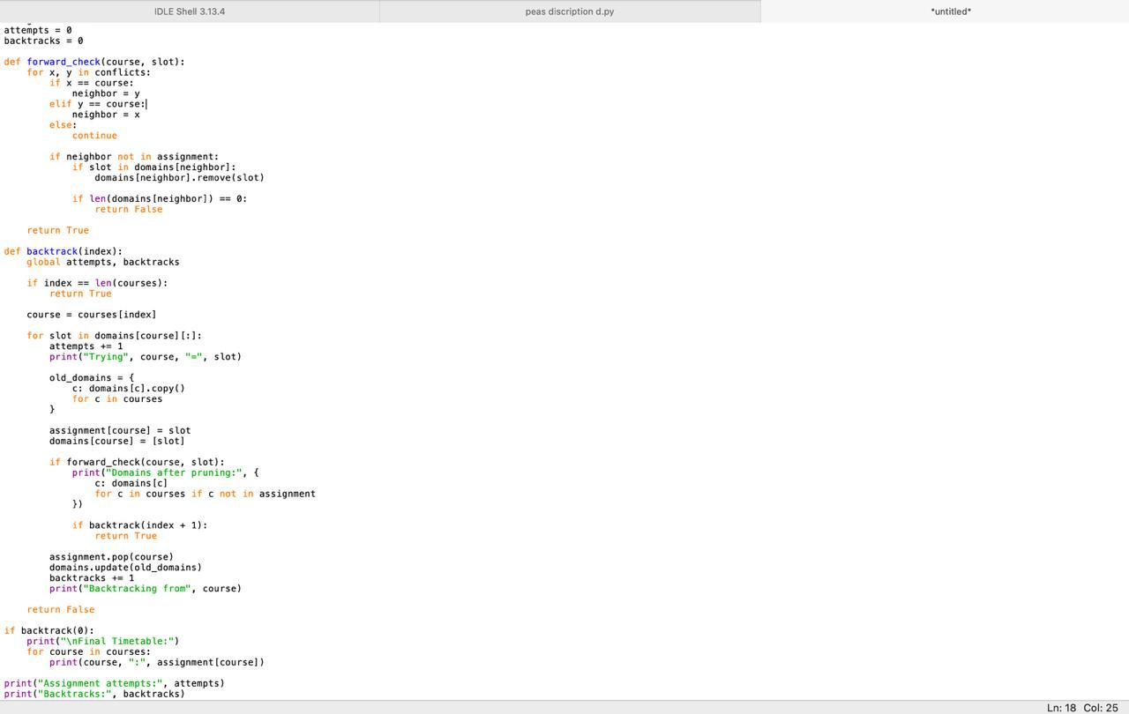

Output:
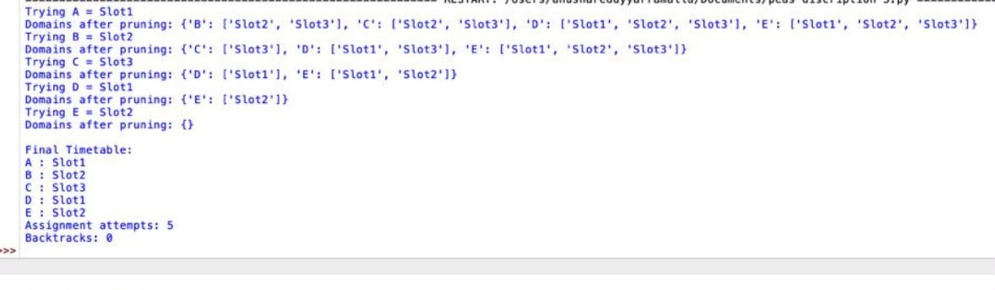

f) Comparison
Measure | Plain Backtracking | Backtracking + Forward Checking
Assignment attempts | 9 | 5
Rejected (failed) attempts | 4 (B=S1, C=S1, C=S2, E=S1) | 0
Backtracks to earlier variables | 0 | 0
Consistency work | Done at assignment time, after the value is picked | Done once per assignment by pruning neighbours
Early failure detection | No (conflict found only when the variable is reached) | Yes (empty domain detected immediately)
Solution found | A=S1, B=S2, C=S3, D=S1, E=S2 | Same

Why forward checking reduces search effort
- Prunes in advance. Conflicting values are removed from neighbours' domains as soon as a variable is assigned, so they are never tried later (B=S1, C=S1, C=S2 and E=S1 were never attempted).
- Early dead-end detection. If a neighbour's domain becomes empty, the algorithm backtracks at once instead of discovering the dead end several levels deeper. That did not happen on this instance, but it is the main source of savings on harder ones.
- Forced moves. Variables whose domains shrink to one value (C, D, E here) are assigned directly with no trial and error.
- Trade-off. Forward checking costs extra work per assignment (updating neighbour domains), but this is small compared with the avoided failed attempts, so overall it is more efficient. Here it cut assignment attempts from 9 to 5 (about 44% fewer).

Input:
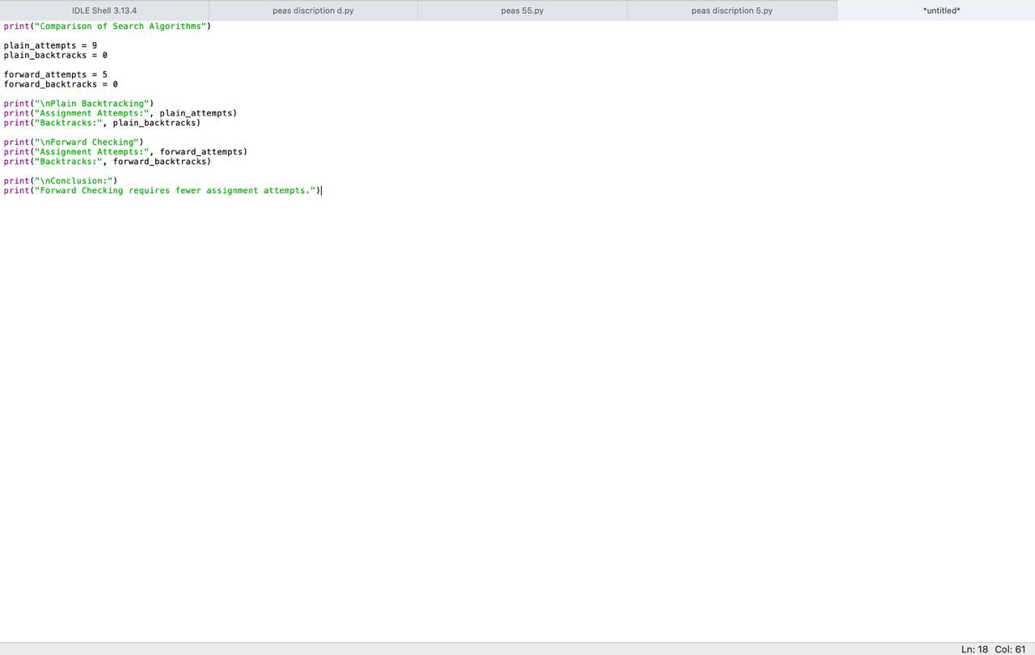
Output:
